Website: https://www.pediatrics.wisc.edu/education/residency-program/pathways/global-health/#current-residents

Global Health
Overview & Vision
The University of Wisconsin Pediatric Residency Program’s focus on child global health and advocacy led to the launch of the Global Health Track in 2010-2011. What began as a resident-driven initiative blossomed into a longitudinal curriculum that spans all three years of residency. Its multidisciplinary nature provides residents with opportunities and relationships across the institution, the U.S., and abroad.
The Global Health Track for pediatric residents is designed to foster personal growth while teaching topics and providing tools that will serve them in their careers. Residents have the opportunity to engage in local global experiences in addition to international and domestic rotations in a variety of locations that emphasize ethical and sustainable partnerships.
An overview of training opportunities for Pediatric Residents in the Global Health Track can be viewed in our UW Pediatric Global Training Passport.
Components of the Global Health Track
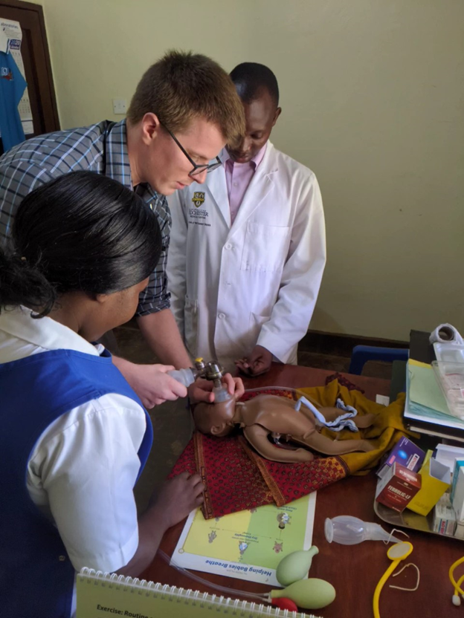
Fundamentals of Global Health
A critical portion of the track is an annual two-week course, typically occurring in the fall. During this protected time, track residents are provided with a comprehensive overview of key issues in global child health, both locally and abroad. The two-week course involves small and large group discussions, case-based learning, simulations, procedural training, and didactics by global health faculty and visitors. The first week of Fundamentals is multidisciplinary, including the Departments of Pediatrics, Obstetrics and Gynecology, Family Medicine, Internal Medicine, and Emergency Medicine, which provides a broad range of perspectives and experiences and connects residents to others in the field of global health. Our second week focuses on collaboration between the Pediatric and Family Medicine residents to discuss topics, participate in simulations, and engage in the community on issues that affect pediatric patients. Course materials (and recorded presentations) are all on UW’s Canvas platform, and a brief summary of the course curriculum is available here.
Local Global Partnerships
During the second week of Fundamentals, pediatric residents often participate in local global partnerships that provide opportunities for local advocacy. Recent projects have focused on collaboration with Centro Hispano, a non-profit that provides services to Latino community members in Dane County. Residents have assisted with the curriculum development for training of community health workers (promotoras) who provide perinatal and infant education to new mothers. Track leaders partner closely with advocacy educators and experts to effectively engage track residents in local opportunities.
Strong Mentorship
Residents enrolled in the track are assigned global health mentors who help guide them throughout the course of their residency training and connect them with the resources available across UW–Madison to help them meet their personal goals. Mentors are also helpful in choosing a global health rotation.
Evening Sessions
Global Health Track residents meet approximately one night a month to discuss a global health topic. This is also the forum for mid-year and graduation celebrations as well as an annual book club, with the book chosen by track residents.
Participation in a Global Health Elective
Track residents are encouraged, but not required, to participate in a global health elective during their residency training. International opportunities are available through University of Wisconsin partnerships in Uganda (ATLAS International) and other regions (dependent on current faculty involvement). Local global opportunities are available through the Center for Special Children in LaFarge, Wisconsin (offering a unique experience working with Plain communities) and Indian Health Services. Residents may participate in electives in other locations as well.
The Big Picture
Our residency offers the opportunity to connect with a large, active, and internationally renowned graduate and undergraduate campus network. The University of Wisconsin-Madison Global Health Institute spans the campus and brings together faculty and students from across all disciplines to address health care, food security and sustainable agriculture, water and sanitation, environmental sustainability, and “one health” perspectives that integrate the health of humans, animals, and the environment. Through these networks, residents can work with and learn from professionals from an array of disciplines across campus.
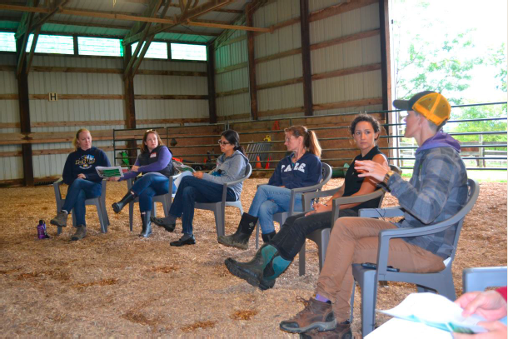
Hear From Our Residents
View a current roster of our Global Health Track residents and review the bios of this diverse and remarkable group. To see all of the prior UW Pediatric Global Health Track graduates (and briefly review some of their scholarly and global health elective experiences during residency), click here.


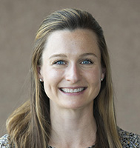
A robust global health curriculum is one of the big reasons I pursued residency at UW and it has surpassed my expectations.
Our monthly meetings with engaging presenters and topics are something I look forward to. Likewise, the fundamentals course is extremely well organized and filled with exceptional speakers, challenging discussions and simulations to prepare us for the realities of global health work. It’s nice to know that this experience is valued by residency leadership by making it protected time for all the residents involved. Being in the global health track is important to me because it not only provides the frame work to participate in effective clinical work around the world, but to also better understand the lived experience of the varied patient population in the US.
Paige Condit, MD (PGY-3)
- Track Leaders
- Core Faculty
- Affiliate Faculty
- Current Residents
- Past Participants
View a current roster of our Global Health Track residents
Review the bios of our Global Health Track residents
Faculty Expertise, Research, and Resources
Below is a sampling of academic work by Pediatric Global Health Track faculty leaders on the role of global health in pediatric residency education. Residents have the opportunity to participate in scholarly projects with a global health focus through the track. Recent research and relevant publications can be found on the Division of Global Pediatrics webpage.
Curricula
Global Health in Pediatric Education: An Implementation Guide for Program Directors is a publication of the American Board of Pediatrics Global Health Task Force (2018). It is a comprehensive, practical resource for incorporating global health education into pediatric training programs. Dr. St Clair led the development of the guide in collaboration with Dr. Butteris and many colleagues across the international global health educator community.
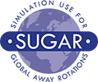SUGAR (Simulation Use for Global Away Rotations) is a suite of free educational products used to prepare medical providers to work in resource-limited settings. It was co-created by Dr. Butteris and colleague Dr. Mike Pitt from the University of Minnesota and piloted by the Midwest Consortium of Global Child Health Educators. Facilitators have been trained at over 100 institutions across the world. SUGARPREP consists of the SUGAR Trio, a comprehensive set of curricular resources for use by global health educators. The Trio is comprised of:
- SUGAR (Simulation Use for Global Away Rotations) Sim Cases: a simulation-based curriculum that focuses on common challenges, both practical and emotional, faced when working in resource-limited settings.
- PEARLS (Procedural Education for Adaptation to Resource-Limited Settings): a series of downloadable or streaming videos that demonstrate how to modify medical procedures using supplies commonly found in resource-limited settings.
- S-PACK (SUGAR’s Pre-Departure Activities Curricular Kit): a comprehensive pre-departure global health curriculum that is modular and modifiable.
Additional resources developed by the Midwest Consortium of Global Child Health Educators can be found at sugarprep.org.
Global School Health
Developed by a former UW Pediatrics Global Health Track graduate in collaboration with UW Global Pediatrics faculty, the American Academy of Pediatrics (AAP) Section on Global Health, the AAP Council on School Health, and national colleagues, the Global School Health Toolkit is an online, practical resource for pediatric providers from high-income countries with little or no prior school health expertise who are seeking to engage in school-based health initiatives in low- and middle-income countries. Informed by an extensive literature and needs assessment, this comprehensive toolkit is a remarkable resource for anyone engaging with school communities.
Applying for the Global Health Track
Following Match Day, all incoming residents will have the opportunity to apply for the Global Health Track. Selected residents will begin participating in the track during their intern year.
For questions about the Global Health Track, please email the Global Health Chief at chiefresidents@pediatrics.wisc.edu.

