Disseminate Scholarship of Teaching:
How to Publish a Teaching Tool or Curriculum

Facilitator:
Adam D. Wolfe, MD, PhD (adam.wolfe@bcm.edu)
Materials co-curated by: Anne Gill, DrPH, MS, RN (gill@bcm.edu)
Objectives:
- Describe the quality standards for scholarship of teaching that can be used to guide a successful scholarly project and publication
- Analyze the available venues for publishing education materials, using MedEdPORTAL as a reference example
- Outline a plan for implementing, evaluating, revising, and publishing an individual’s education materials
Agenda:
9:00-9:10 Introduction, review objectives, learner activation
9:10-9:20 Individual preparation: Goals and objectives brainstorm
9:20-9:30 Mini-didactic: Glassick criteria, objectives, and Bloom’s taxonomy
9:30-9:40 Small groups: Share and revise objectives
9:40-9:50 Mini-didactic: Glassick criteria, preparation, methods, results
9:50-10:00 Individual preparation: Needs assessment, teaching methods, evaluation strategy
10:00-10:20 Small groups: Share project plans, step back critiques, refine plans
10:20-10:35 Effective presentation: MedEdPORTAL and publishing strategies
10:35-10:50 Small groups: Barriers and strategies to strengthen presentation
10:50-11:00 Large group: Summary, take home points, discussion
Handout Contents:
- Glassick criteria 2
- Bloom’s taxonomy, sample verbs 3
- Publishing educational scholarship: Resources 4
- Kirkpatrick’s hierarchy & New World Kirkpatrick model 5
- MedEdPORTAL guidelines 6
- MedEdPORTAL Submission Review Checklist 7
- MedEdPORTAL Review Criteria Alignment Guide 8-9
- Low Hanging Fruit: thoughts on different ways to publish in education 10

Glassick Criteria

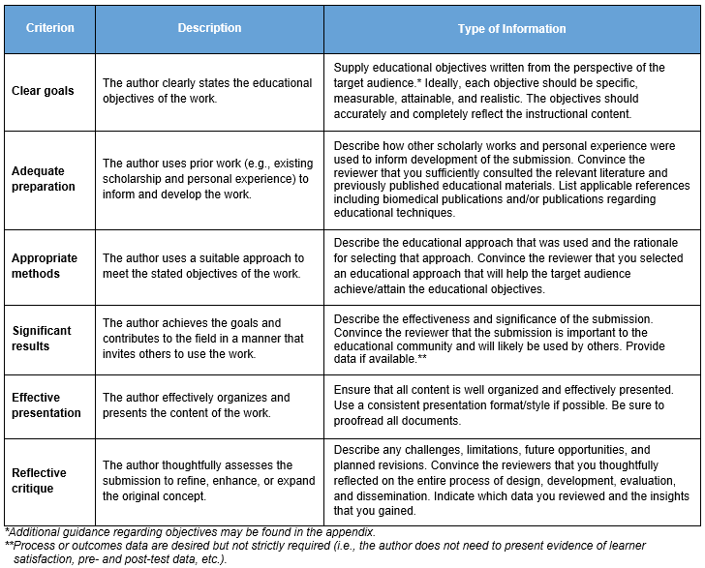

Action verbs by cognitive levels of Bloom’s taxonomy
http://chiron.valdosta.edu/whuitt/col/cogsys/bloom.html

Writing for MedEdPORTAL?
Avoid the verbs: Know, Understand, Learn, Appreciate, Become, Grasp the significance of

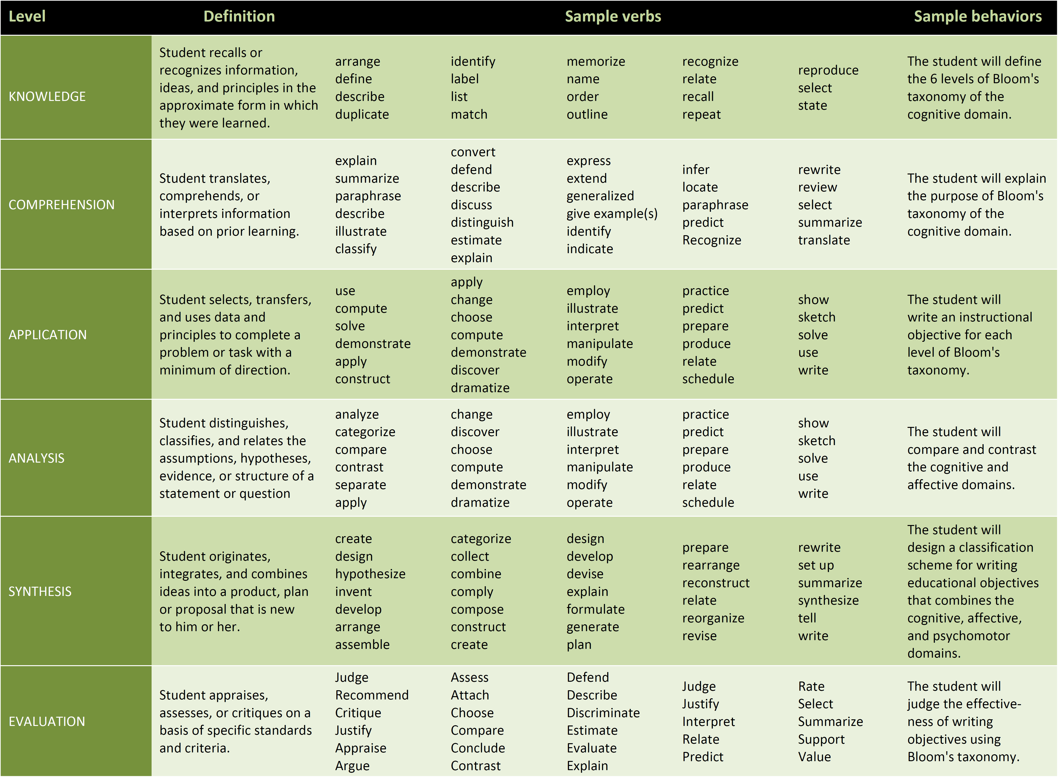
Publishing educational scholarship: Resources
AAMC’s Annotated Bibliography of Journals for Educational Scholarship (09/2022 version):
https://www.aamc.org/media/38166/download
Sites that host education tools and curricula:
- MedEdPORTAL (www.mededportal.org) – Peer reviewed medical education content hosted by the Association of American Medical Colleges, welcomes material aimed all levels of medical learner in all disciplines
- MedEdPublish (www.mededpublish.org) – Peer reviewed medical education content hosted by the Association for Medical Education in Europe
- CES4Health.info (www.CES4Health.info) – Peer reviewed source for educational tools resulting from health-related community-engaged scholarly work that is conducted in partnership with communities
- MERLOT (merlot.org/merlot/) – Curated on-line archive of higher education curricula and learning tools, with recent emphasis on virtual learning opportunities. Not medicine-specific.
A List of High-Impact Medical Education Journals
https://www.osmosis.org/blog/2020/02/10/a-list-of-highimpact-medical-education-journals
Journals that publish education research content (per AAMC; underlined entries may be of particular interest):

Academic Medicine
Academic Pediatrics
Academic Psychiatry
Academic Radiology
Advances in Health Sciences Education
American Journal of Medicine
American Journal of Obstetrics and Gynecology
American Journal of Preventive Medicine
American Journal of Surgery
Annals of Family Medicine
Best Evidence in Medical Education (BEME)
BioMed Central Medical Education
British Medical Journal
Canadian Medical Education Journal
Education for Health
Evaluation & the Health Professions
Family Medicine (Society of Teachers of Family Medicine)
Focus on Health Professional Education
International Journal of Clinical Skills
Journal of the American Medical Association (JAMA) ‐ Annual Medical Education Issue (September)
Journal of Biomedical Education
Journal of Cancer Education
Journal of Clinical Anesthesia
Journal of Continuing Education in the Health Professions
Journal of Dental Education
Journal of General Internal Medicine (JGIM)
Journal of Graduate Medical Education
Journal of Hospital Medicine
Journal of Interprofessional Care
Journal of Nursing Education
Journal of Surgical Education
Journal of the National Medical Association
Journal of Veterinary Medical Education
Medical Education
Medical Education Development
Medical Education Online: an Electronic Journal
Medical Science Educator
Medical Teacher
New England Journal of Medicine ‐ education pieces included several times a year
Nurse Education in Practice
Nurse Education Today
Obstetrics and Gynecology
Teaching and Learning in Medicine
The Clinical Teacher
The Internet Journal of Allied Health Sciences and Practice
The Open Medical Education Journal

Kirkpatrick’s hierarchy
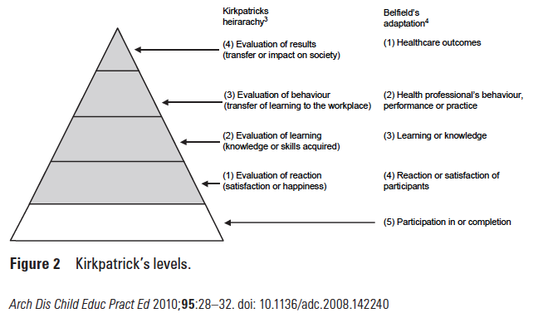

The New World Kirkpatrick Model
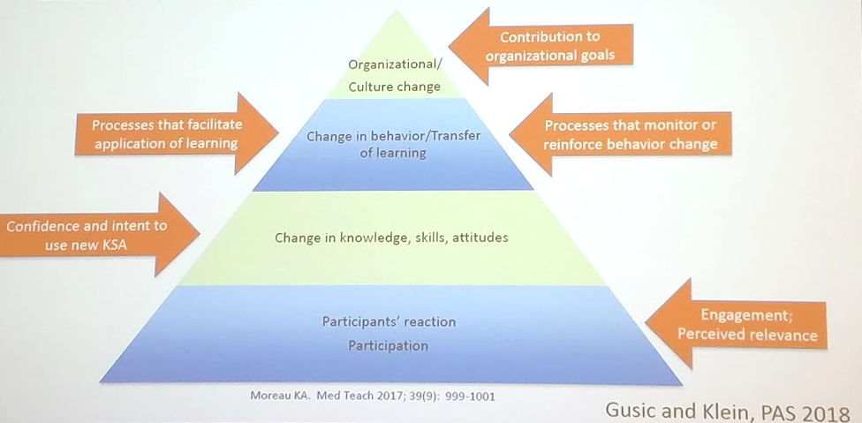
MedEdPORTAL Guidelines
- Review all guidelines and instructions at: https://www.mededportal.org/author

- Tips for successful publishing at the Author Center: https://www.mededportal.org/authorcenter

- Prepare Educational Summary Report (ESR). Address all Glassick criteria from table below within the ESR.
  - Templates available at the above link – use the appropriate, up-to-date template! Follow the template exactly, do not change fonts, spacing, margins, organization, etc. or it may be sent back to you for correction by the editorial office.
  - Title, Authors, Affiliations, Acknowledgments
  - Structured Abstract (250 word limit): Introduction, Methods, Results, Discussion
  - Educational Objectives (use SMART criteria, elevate cognitive levels in Bloom’s taxonomy)
  - Introduction (summarize relevant prior work including anything similar already in MedEdPORTAL, identify the gap addressed by this submission, describe target audience)
  - Methods (e.g., educational approaches used, should adequately address the Objectives)
  - Results (effectiveness of the educational tool at accomplishing Objectives, use Kirkpatrick’s hierarchy and aim for as high a level as possible).
  - Discussion (summarize process of development, implementation, evaluation, and lessons learned from reflective critique). Also address how adaptable the resource is to maximize its generalizability.
  - Appendices (include all materials needed to implement the teaching tool, e.g., electronic slides, handouts, pocket cards, videos, instructions)
  - References

- Key reasons a submission is rejected (cited by MedEdPORTAL and other journal editors at AAMC). Make sure the submission meets these standards.
  - Insufficient educational context or too locally focused (i.e., not generalizable).
  - Mismatch of educational Objectives and instructional content.
  - Resource does not contribute to the field (e.g., too superficial, or only reference materials not practical for teaching).
  - Lack of evidence of effectiveness or outcomes.
  - No impact on practice.

MedEdPORTAL Submission Review Checklist

ESR Review
Abstract | - Provides a complete summary of the introduction, methods, results, and discussion.
Objectives | - Are SMART. (Use active, measurable verbs; avoid understand and be familiar with.)
Introduction | - Describes rationale for developing the resource (i.e., educational gap; unique content, methodology or both)?  - Appropriately cites relevant literature (either includes MedEdPORTAL sources or a statement that none were found)  - Describes in general terms the target audience
Methods | - Describe how the resource was implemented  - preparation/learner prerequisites  - timing/training level of target audience  - resources needed  - physical setting  - personnel  - Describes how the resource was evaluated.  - Mentions all appendices.  - Is in past tense, active voice, third person.
Results | - Presented in the appropriate format (text, table, figure)  - Sufficient to demonstrate the effectiveness or impact of this resource.  - Support the context of the submission (consistency and alignment of learning objectives, implementation methods, and assessment methods)
Discussion | - Begins with a statement of the key contribution of this resource  - Summarizes of what was done in the context of the rationale (reflection on the Introduction)  - Describes lessons learned, including departures from convention (reflection on the Methods)  - Includes interpretation of outcomes and efficacy (reflection on the Results)  - Describes limitations (reflection on the evaluation methods)  - Provides recommendations for the reader or end-user

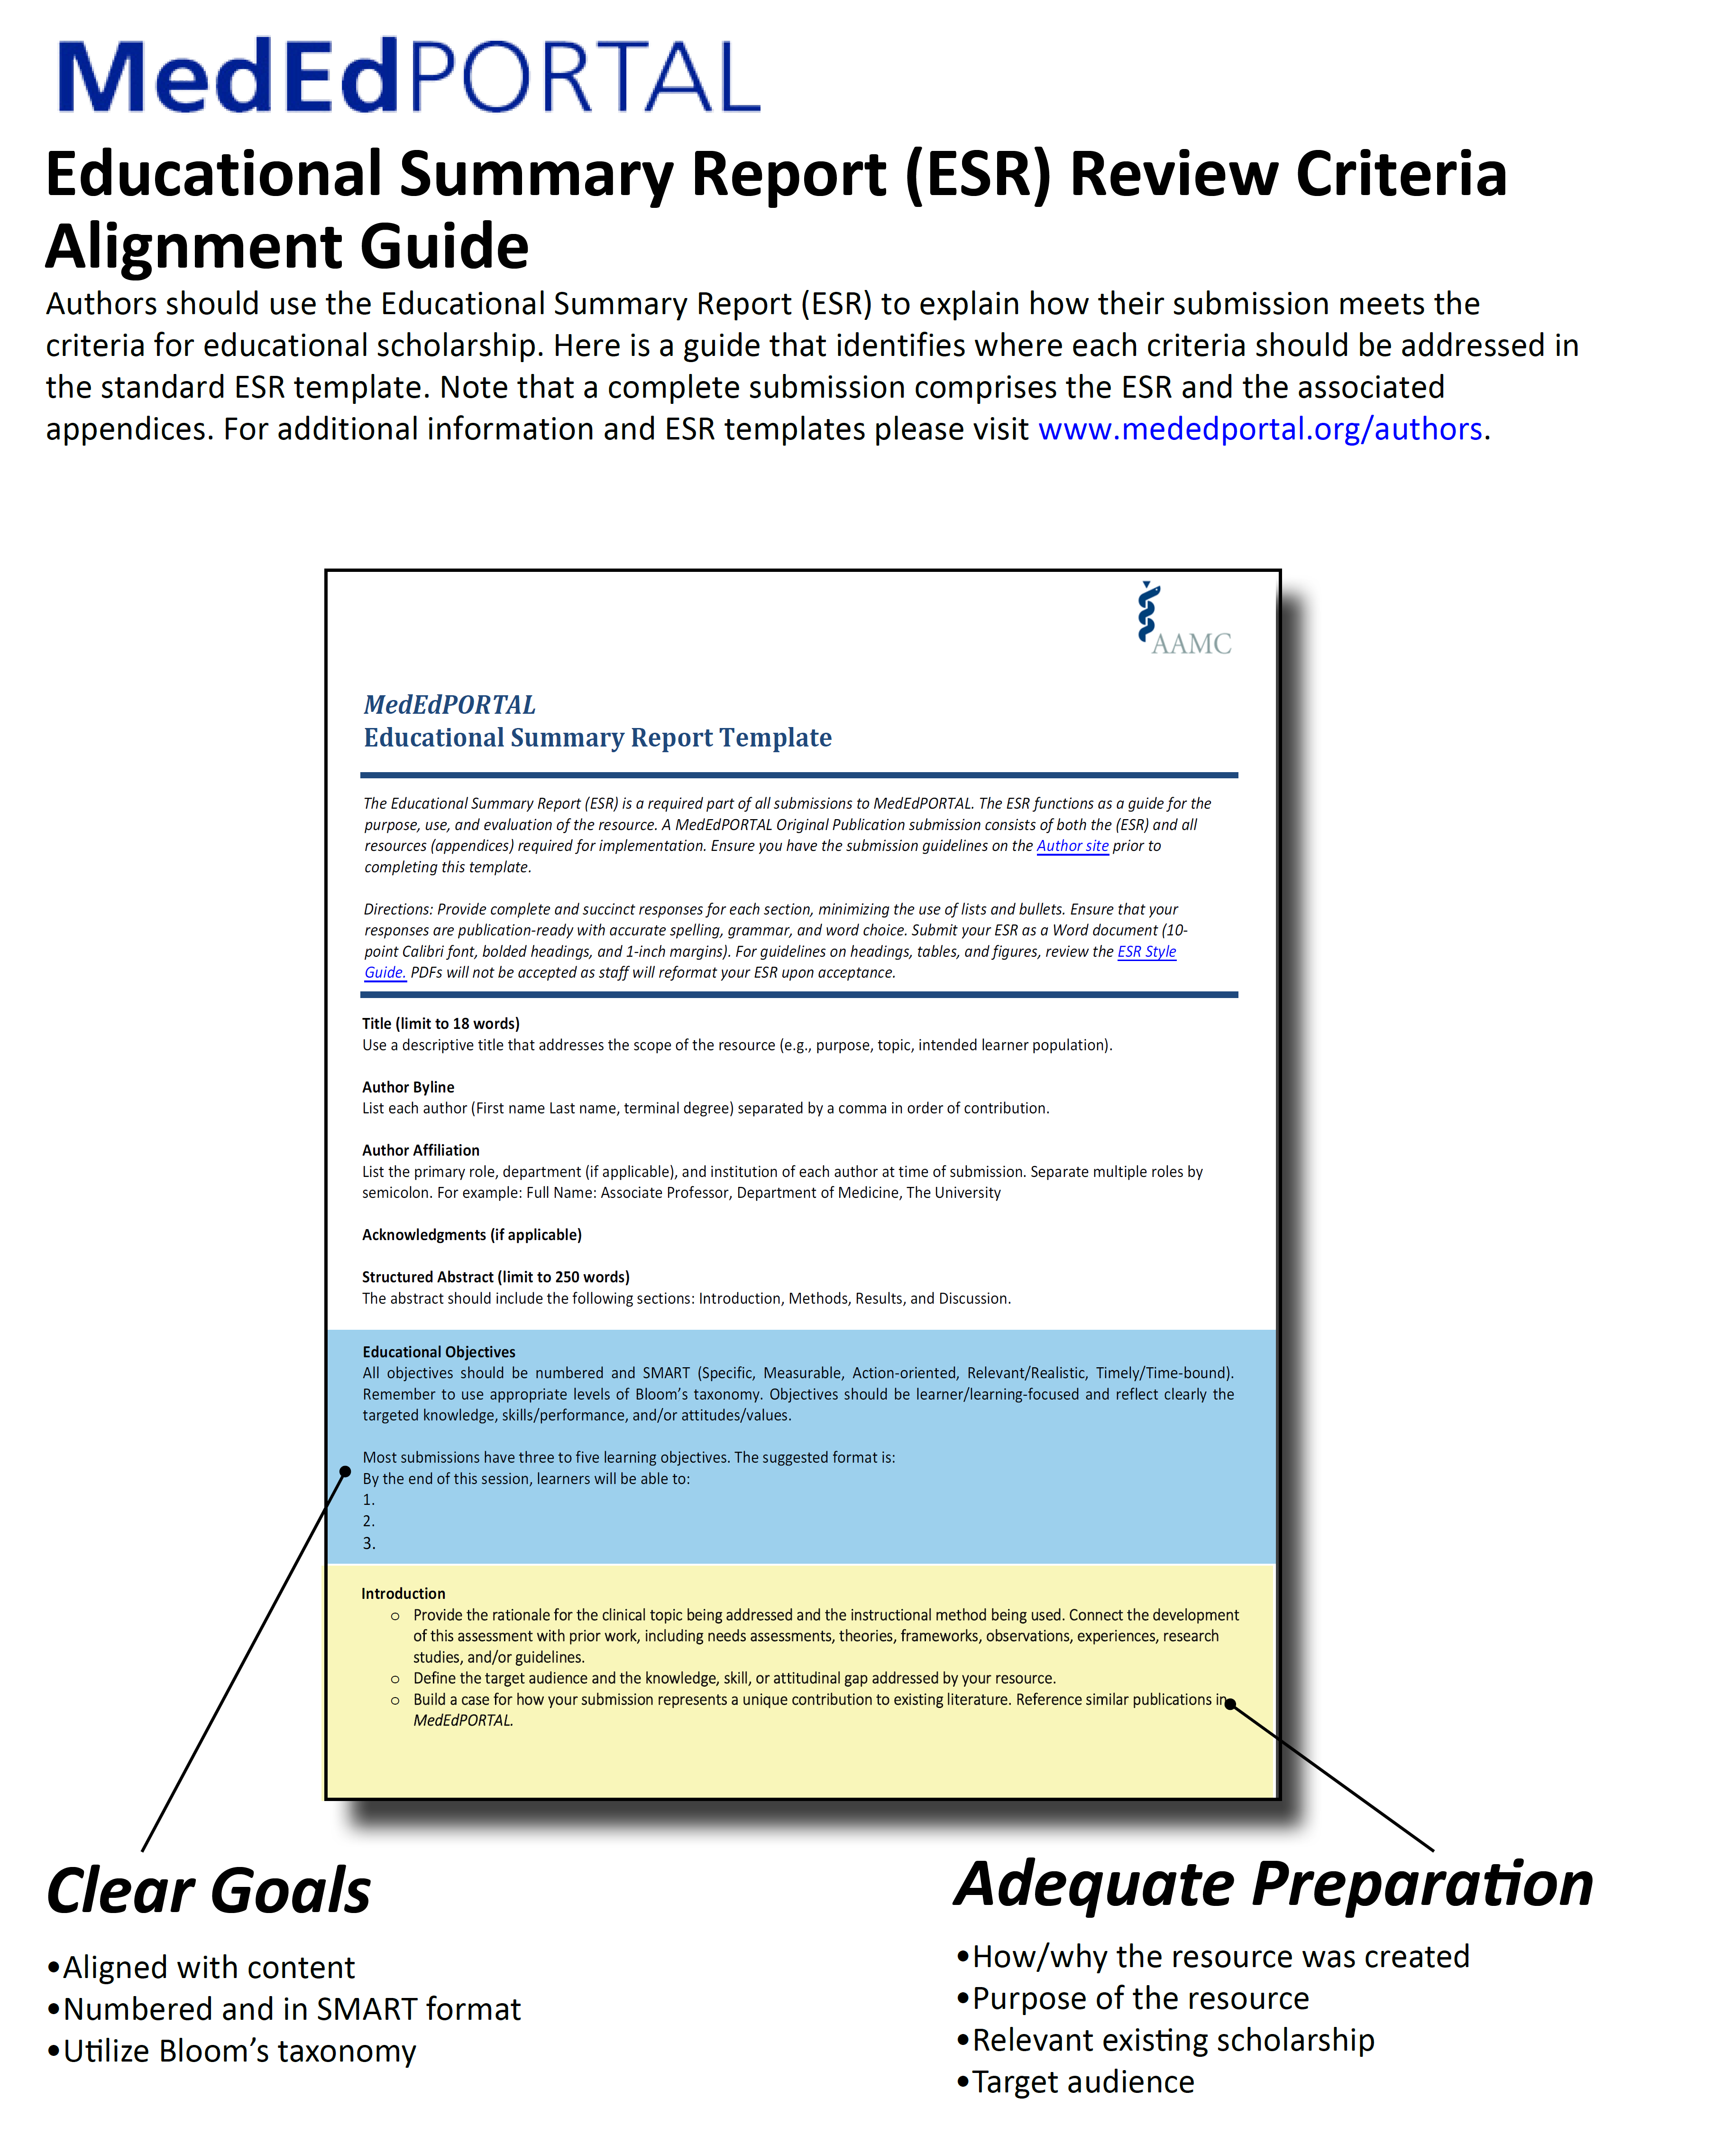

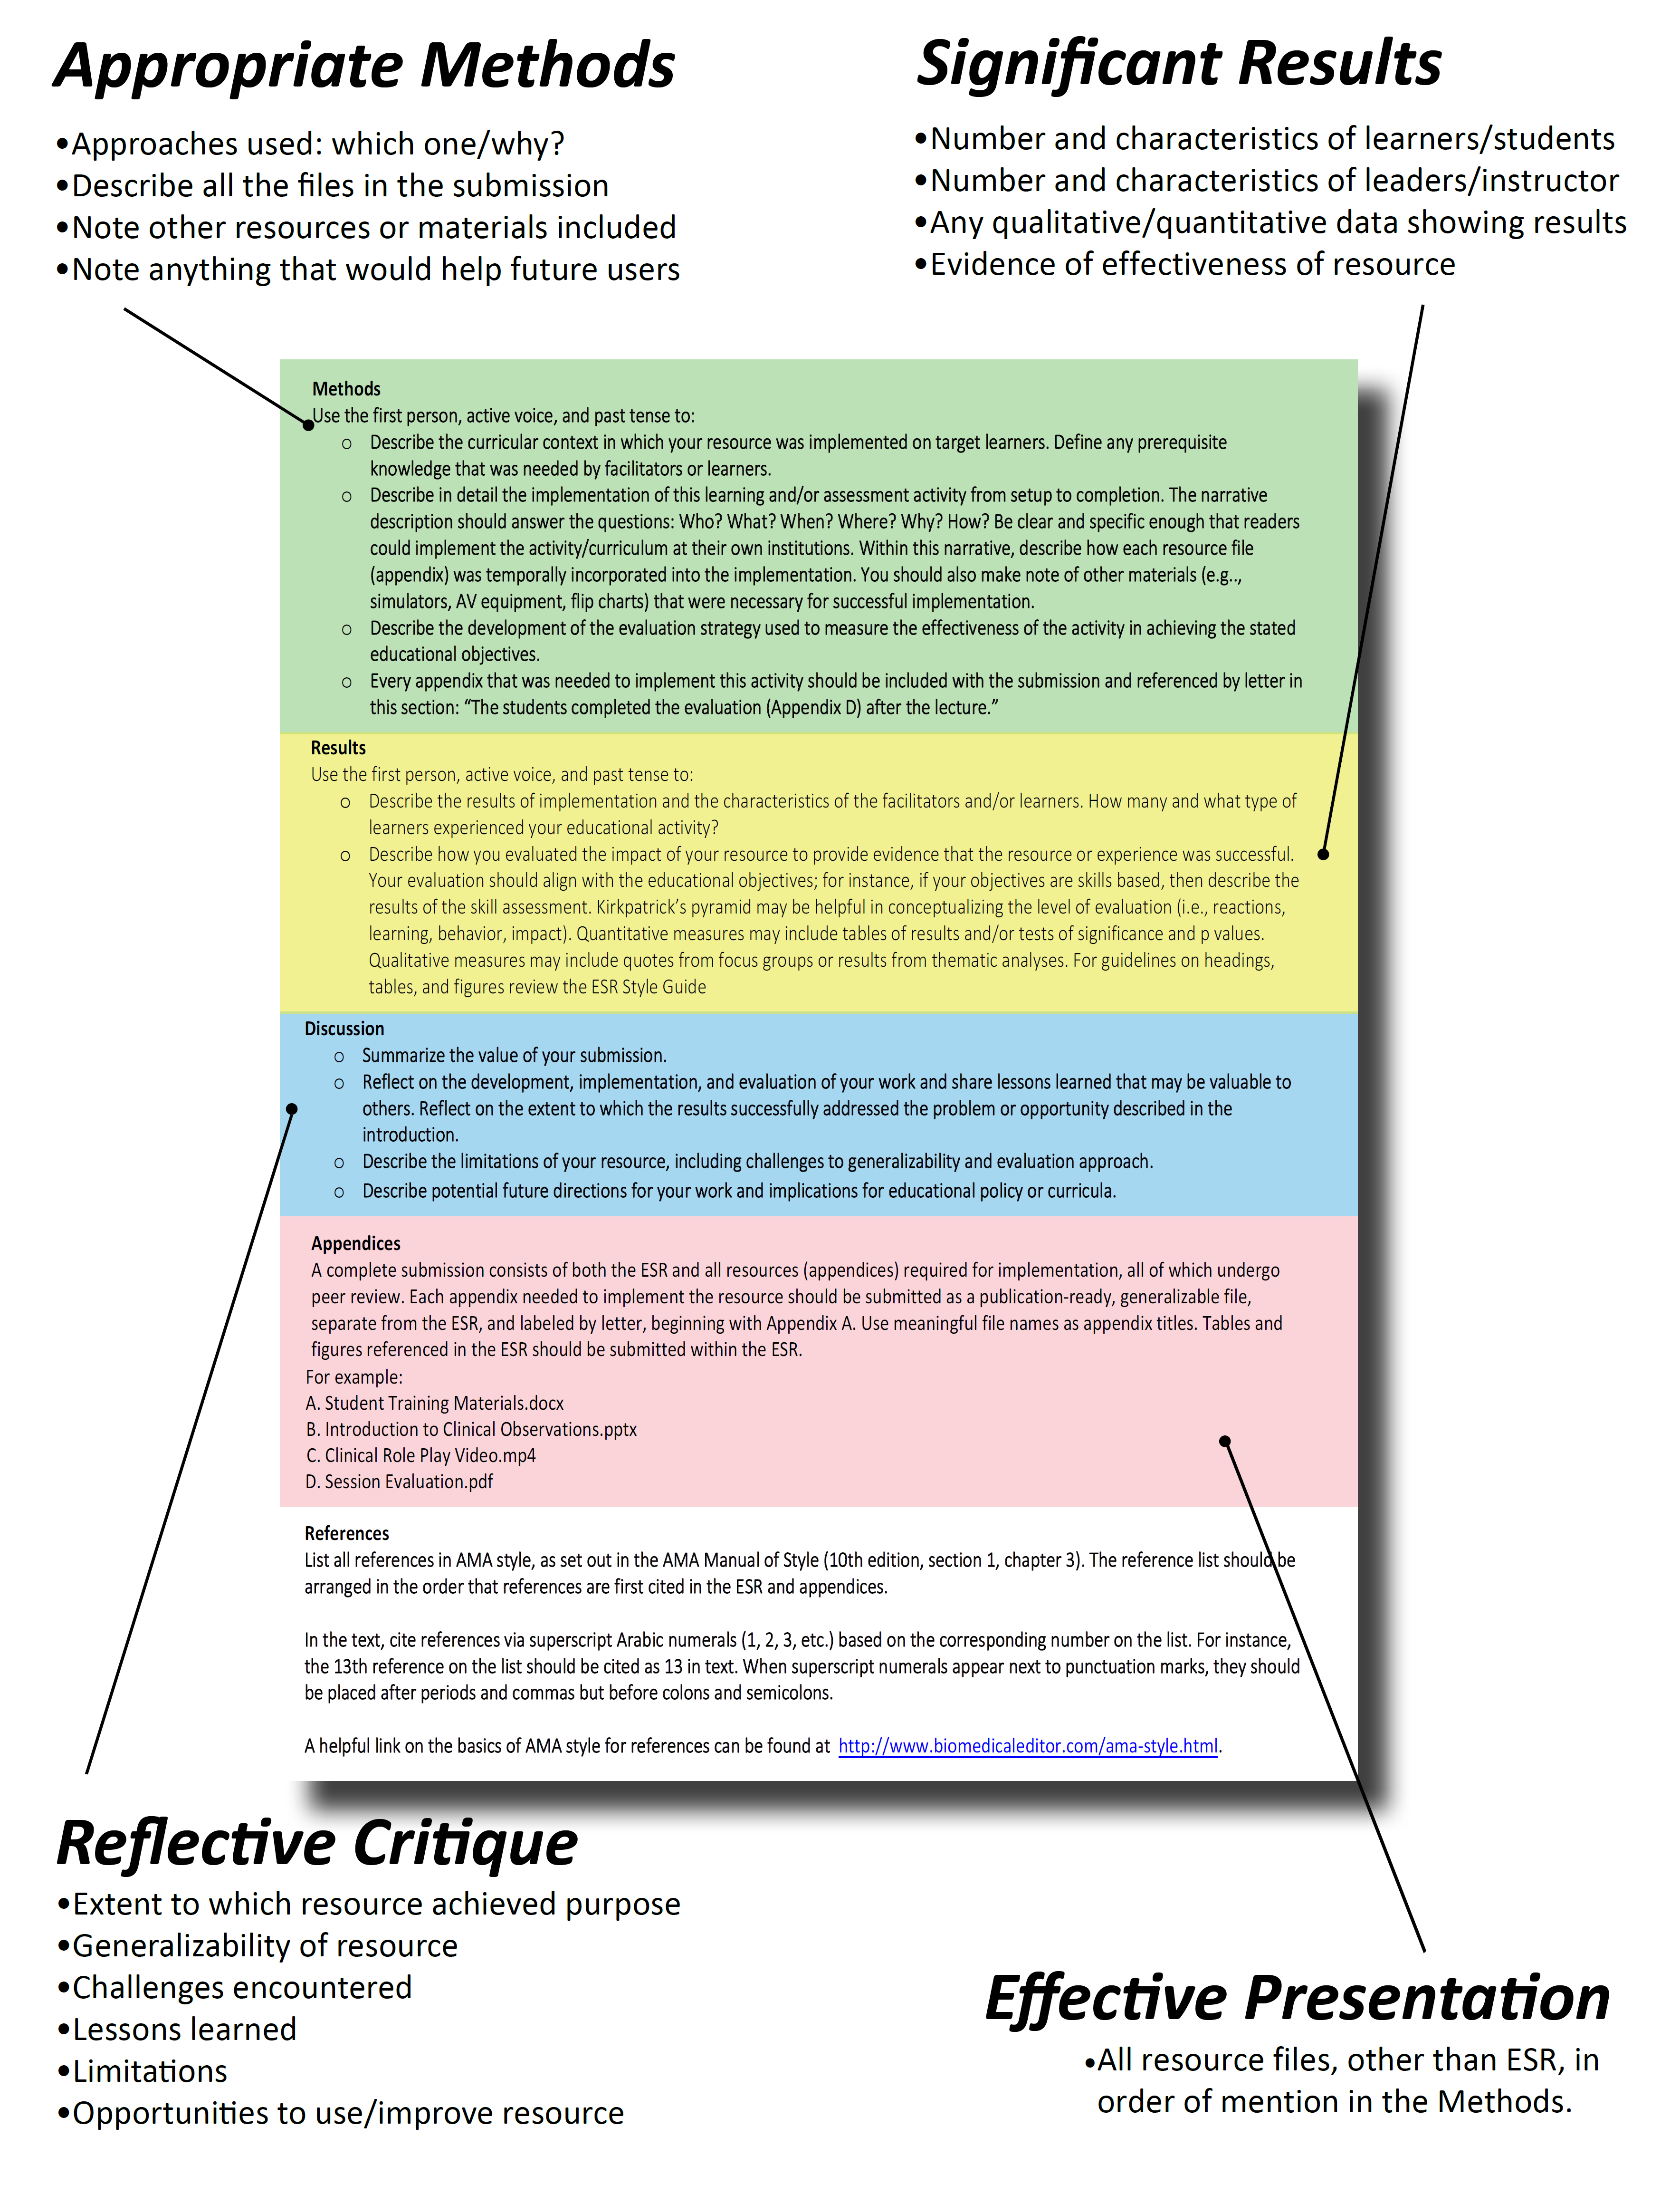

http://feedtheeducator.blogspot.com/2014/04/mmmmmm-low-hanging-fruit.html

