Curriculum Development and Evaluation Guide

Creating Endurable Change:

How to Develop Medical Education Curricula

APPD Pre-Conference Workshop

April 2014

Nicole Paradise Black, MD, MEd, University of Florida

Rebecca Blankenburg, MD, MPH, Stanford University

Cynthia Ferrell, MD, MSEd, Oregon Health & Science University

H. Barrett Fromme, MD, MHPE, University of Chicago

Christine Skurkis, MD, University of Connecticut

*Please use this handout as a summary of Kern’s steps and an active workbook for your own curricular development*

Adapted with permission,

from J. Farnan & N. Schindler @ Pritzker School of Medicine

Kern’s Six-Step Approach1:

1. Problem Identification and General Needs Assessment
2. Needs Assessment of Targeted Learners
3. Goals and Objectives
4. Educational Strategies
5. Implementation
6. Evaluation and Feedback

1 Kern, David E. and Patricia A. Thomas, Donna M. Howard, Eric B. Bass. Curriculum Development For Medical Education: A Six-Step Approach. Johns Hopkins University Press: Baltimore and London, 2006.

Step 1: Problem Identification and General Needs Assessment

What is the problem (in form of question)?

Consider whom and what it affects?

What is the IMPACT of these effects?

F

A

C

T

O

R

S

Predisposing

Reinforcing

Enabling

|  |  |
| --- | --- |
| Current Approach | Ideal Approach |
|  |  |

Step 2: Needs Assessment of Targeted Learners

*Identify* target audience

Who are the stakeholders?

|  |  |
| --- | --- |
| Stakeholder | Role/How impacted by problem? |
|  |  |
|  |  |
|  |  |
|  |  |

What information do you need from them?

|  |  |
| --- | --- |
| Stakeholder | Relevant information |
|  |  |
|  |  |
|  |  |
|  |  |

How will you obtain the information?

|  |  |  |
| --- | --- | --- |
| Stakeholder | Method for Assessment | Resources Required |
|  |  |  |
|  |  |  |
|  |  |  |
|  |  |  |

***RIGOROUS TARGETED NEEDS ASSESSMENT***

***= OPPORTUNITY FOR SCHOLARSHIP***

Step 3: Goals and Objectives

Consider and construct overall educational goal:

List *specific* *measurable* learning objectives:

|  |  |  |  |
| --- | --- | --- | --- |
| Level of Learner  (individual vs. program)  **“who”** | Type of Objective  (learner, process, outcome) | Will do **how much/how well** of **what?** | By **when**? |
|  |  |  |  |
|  |  |  |  |
|  |  |  |  |
|  |  |  |  |
|  |  |  |  |
|  |  |  |  |

|  |  |
| --- | --- |
| Bloom’s Category | Key words/Verbs |
| Knowledge | defines, describes, identifies, knows, labels, lists, names, outlines, recalls, recognizes, reproduces, states |
| Comprehension | comprehends, converts, defends, distinguishes, estimates, explains, , generalizes, interprets, paraphrases, predicts, summarizes, translates |
| Application | applies, changes, constructs, demonstrates, discovers, manipulates, modifies, operates, prepares, produces, relates, shows, solves, uses |
| Analysis | analyzes, compares, contrasts, diagrams, differentiates, discriminates, distinguishes, identifies, illustrates, infers, outlines, relates |
| Synthesis | categorizes, combines, compiles, composes, creates, designs, generates, modifies, organizes, plans, reconstructs, reorganizes, revises, summarizes, |
| Evaluation | appraises, compares, concludes, contrasts, critiques, defends, discriminates, evaluates, interprets, justifies, relates, summarizes, supports |

*http://www.nwlink.com/~donclark/hrd/bloom.html*

Step 4: Educational Strategies

Create 1-2 Educational Strategies: Consider congruence between learning objectives and methods, the use of multiple instructional methods, learner-centered environment and feasibility based on resources

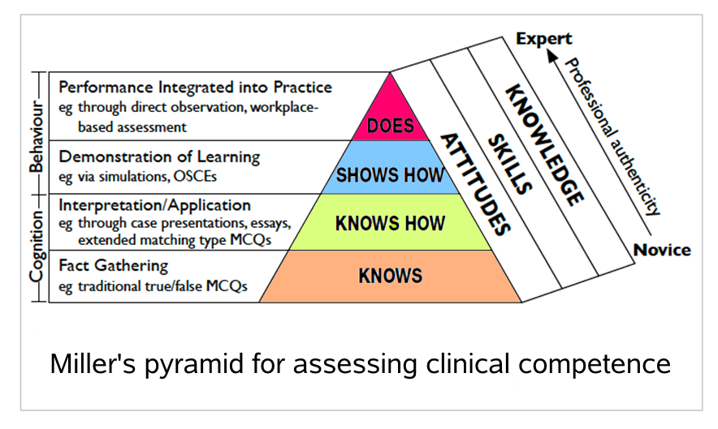

|  |  |  |  |
| --- | --- | --- | --- |
| Type of Objective | Specific Learning Objective | Educational Strategies | Resources required? |
|  |  |  |  |
|  |  |  |  |
|  |  |  |  |
|  |  |  |  |
|  |  |  |  |

Plan for prevention of decay?

Step 5: Implementation

FIRST! Consider support for curriculum? Whose buy-in is required prior to implementation?

Identification of Resources:

|  |  |  |
| --- | --- | --- |
| Resource | Existing? | Additional needs? |
| Personnel:  Teaching support-  Administration- |  |  |
| Time |  |  |
| Space |  |  |
| Funding/Costs |  |  |
| Other: |  |  |

Step 5: Implementation

Possible sources of support?

|  |  |
| --- | --- |
| Internal funding sources? | External funding sources? |
|  |  |

Recognizing and Planning for Barriers:

|  |  |  |
| --- | --- | --- |
| Resource | Barrier? | Potential solution? |
| Personnel:  Teaching support-  Administration- |  |  |
| Time |  |  |
| Space |  |  |
| Funding/Costs |  |  |
| Other: |  |  |

Step 5: Implementation

FULL IMPLEMENTATION:

PHASE IN:

T

I

M

E

L

I

N

E

PILOT:

Step 6: Evaluation and Feedback

Consider the USE for the evaluation and identify the users:

Formative vs. Summative evaluation:

|  |  |  |
| --- | --- | --- |
|  | Summative | Formative |
| Individual learner |  |  |
| Programmatic evaluation |  |  |

Data Collection:

|  |  |  |
| --- | --- | --- |
|  | Type of evaluation/Methods | Resources required |
| Individual learner |  |  |
| Programmatic evaluation |  |  |

|  |  |
| --- | --- |
| Level | Outcome |
| 1 | Reaction – was the learner satisfied with the curriculum |
| 2A | Learning – change in attitudes |
| 2B | Learning – modification of knowledge or skills |
| 3 | Behavior – changes in behavior |
| 4A | Results – change in system or organizational practice |
| 4B | Results – change among the participants’ and peers |

**Kirkpatrick’s Levels of Evaluation**

***RIGOROUS EVALUATION =OPPORTUNITY FOR SCHOLARSHIP***

Curriculum Maintenance and Dissemination

Individual learner feedback

Programmatic evaluation results

Informal observations

Lessons learns from barriers

New challenges which arise…

Planning for management of change?

Related resources (networking, colleagues, etc)

Sustaining the curriculum

Dissemination= Opportunity for Scholarship!

*WHAT* can be disseminated? Parts or the whole?

* Needs assessment, general and targeted
* Educational strategies
* Evaluation (individual and programmatic) results
* The curriculum as a “package”

*WHERE* can it be disseminated?

* Internal presenting opportunities
* Educational innovations or abstracts for regional and national meetings (e.g., APPD, PAS, PHM, etc)
* Creation of multi-institution interest group regarding topic in question addressed by curriculum
* Social networking
* Educational clearinghouses, repositories (e.g., AAMC MedEd PORTAL)
* Formal publication

**Curriculum Development Worksheet**

|  |  |  |  |
| --- | --- | --- | --- |
| **Problem Identification**   * What is the problem? * Who does it affect? | **General Needs Assessment**  € Lit Search  € Other resources? | **Targeted Needs Assessment**  € Formal needs assessment?  € Informal needs assessment?  € What baseline data do I need or have? | **Goal(s)** |
| **Learning Objectives** (Bloom’s Taxonomy) | | **Educational Strategies** (Miller’s Pyramid) | |
| 1. | |  | |
| 2. | |  | |
| 3. | |  | |
| **Implementation**  € Collaborators?  € Resources?  € Skills? Faculty Development?  € Barriers? | | **Program Evaluation** (Kirkpatrick’s Outcomes)  € Learner Assessment?  € Program Evaluation? | |
| **Scholarship**  € Do I need IRB approval for this project?  € Am I systematically documenting the development process?  € Are my objectives, methods, and evaluation outcomes in-line?  € How will I share or disseminate my project? | | | |